MANGOCHI CATHOLIC DIOCESE MOCK EXAMINATIONS
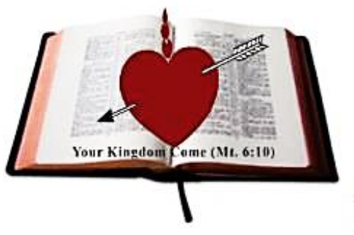
2025 MALAWI SCHOOL CERTIFICATE OF EDUCATION
SOCIAL AND LIFE SKILLS

SUBJECT NUMBER: M192/II
Friday, 16 May 2025 Time Allowed: 2 hrs
1:00 – 3:00 pm
PAPER II
(100 Marks)
Instructions:

- This paper contain 7 printed pages.
Please check

- There are three sections in this paper. A, B and C. Answer all questions in all the three section

- Write your Examination Number on top of each page of question paper

- In the table provided on this page, tick against the question number you have answered

- Hand in your filled in question paper to the invigilator when time is called to stop writing
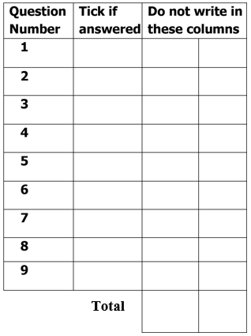

© 2025 MH DIOCESE Turn Over

SECTION A ( 50 marks)

SOCIAL STUDIES
- Answer all the questions in this section in the spaces provided

- a. Mention two cases of violation of human rights for special groups.
_____________________________________________________________________
_____________________________________________________________________
______________________________________________________________(2 marks)

  - Explain two ways of promoting social justice and fairness for special groups.
_____________________________________________________________________
_____________________________________________________________________
_____________________________________________________________________
_____________________________________________________________________
______________________________________________________________(4 marks)

  - Describe two principles of good governance.
_____________________________________________________________________
_____________________________________________________________________
_____________________________________________________________________
_____________________________________________________________________
______________________________________________________________(4 marks)

- a. Mention two effects of devaluation.
_____________________________________________________________________
_____________________________________________________________________
_________________________________________________________________ (2 marks)
  - Explain two ways how devaluation may lead to inflation.
_____________________________________________________________________
_____________________________________________________________________
_____________________________________________________________________
______________________________________________________________(4 marks)

  - Describe two conditions that make development project sustainable.
_____________________________________________________________________
_____________________________________________________________________
continued/…
_____________________________________________________________________
_____________________________________________________________________
______________________________________________________________(4 marks)

- a. Name any two international organizations that promote social justice internationally.
_____________________________________________________________________
_____________________________________________________________________
_____________________________________________________________________
______________________________________________________________(2 marks)

  - Describe any two significance of promoting social justice.
_____________________________________________________________________
_____________________________________________________________________
_____________________________________________________________________ _____________________________________________________________________
______________________________________________________________(4 marks)
  - Explain any two critical issues related to the provision of social services.
_____________________________________________________________________
_____________________________________________________________________
_____________________________________________________________________
_____________________________________________________________________ _____________________________________________________________________
______________________________________________________________(4 marks)

- a. Mention any two electoral process in Malawi.
_____________________________________________________________________
_____________________________________________________________________
______________________________________________________________(2 marks)

  - Explain any two roles of voters in the electoral process in Malawi.
_____________________________________________________________________
_____________________________________________________________________
_____________________________________________________________________ _____________________________________________________________________
______________________________________________________________(4 marks)

continued/…
  - Describe any two preventive and mitigating measures for cyclones
_____________________________________________________________________
_____________________________________________________________________
_____________________________________________________________________ _____________________________________________________________________
______________________________________________________________(4 marks)
- a. Country M receives people from country N because of war. Use this information to
answer questions 5a.

i). What term is given to the people received in country M?
____________________________________________________________ (1 mark)
ii). List any three effects that can be experienced in the host country.
___________________________________________________________________ ___________________________________________________________________ ___________________________________________________________________
____________________________________________________________(3 marks)
  - Explain any two practices that affect the implementation of the population policy in
Malawi.
_____________________________________________________________________
_____________________________________________________________________
_____________________________________________________________________
_____________________________________________________________________
______________________________________________________________(4 marks)

  - Explain any one negative effect of multiculturalism.
_____________________________________________________________________ _____________________________________________________________________
______________________________________________________________(2 marks)

SECTION B (20marks)

LIFE SKILLS
Answer all questions in this section in the spaces provided

- a. State any two ways in which negative peer pressure could affect one's performance at school.
_____________________________________________________________________
continued/…
_____________________________________________________________________
______________________________________________________________(2 marks)

  - Explain any two cultural practices that encourage the spread of HIV in the community.
_____________________________________________________________________
_____________________________________________________________________ _____________________________________________________________________ _____________________________________________________________________
______________________________________________________________(4 marks)

  - Describe two ways of keeping savings.
_____________________________________________________________________
_____________________________________________________________________
_____________________________________________________________________
_____________________________________________________________________
_____________________________________________________________(4 marks)
- a. Mr Matebule wanted to open a business in area X.

i). State any two risks that Mr Matebule could likely face.
___________________________________________________________________ ___________________________________________________________________
____________________________________________________________(2 marks)

ii). Explain two skills that Mr Matebule could use to overcome the risks.
___________________________________________________________________
___________________________________________________________________
______________________________________________________________________
_____________________________________________________________________
____________________________________________________________(4 marks)

b. Describe any two ways how morals and values can be eroded in the society.
_____________________________________________________________________
_____________________________________________________________________
_____________________________________________________________________ _____________________________________________________________________
_____________________________________________________________(4 marks)

continued/…
SECTION C (30 Marks)
ESSAY QUESTIONS
Answer all questions in this section in an essay form in the spaces provided.
8. Explain any five challenges in revenue collection in taxation.
________________________________________________________________________
________________________________________________________________________
________________________________________________________________________
________________________________________________________________________
________________________________________________________________________
________________________________________________________________________
________________________________________________________________________
________________________________________________________________________
________________________________________________________________________
________________________________________________________________________
________________________________________________________________________
________________________________________________________________________
________________________________________________________________________
________________________________________________________________________
________________________________________________________________________
________________________________________________________________________
________________________________________________________________________
________________________________________________________________________
________________________________________________________________________
________________________________________________________________________
________________________________________________________________________
________________________________________________________________________
________________________________________________________________________
________________________________________________________________________
________________________________________________________________________
________________________________________________________________________
________________________________________________________________________
________________________________________________________________________
________________________________________________________________________
________________________________________________________________ (15 marks)

continued/…
9. Explain five ways of assisting peers to build and rebuild their self-esteem.
________________________________________________________________________
________________________________________________________________________
________________________________________________________________________
________________________________________________________________________
________________________________________________________________________
________________________________________________________________________
________________________________________________________________________
________________________________________________________________________
________________________________________________________________________
________________________________________________________________________
________________________________________________________________________
________________________________________________________________________
________________________________________________________________________
________________________________________________________________________
________________________________________________________________________
________________________________________________________________________
________________________________________________________________________
________________________________________________________________________
________________________________________________________________________
________________________________________________________________________
________________________________________________________________________
________________________________________________________________________
________________________________________________________________________
________________________________________________________________________
________________________________________________________________________
________________________________________________________________________
________________________________________________________________________
________________________________________________________________________
________________________________________________________________________
________________________________________________________________________
________________________________________________________________ (15 marks)
END OF QUESTION PAPER
NB: This paper contains 7 printed pages

